sAssignment No 6
1. Write a query that counts the number of salespeople registering orders for each day. (If a salesperson has more than one order on a given day, he or she should be counted only once.).
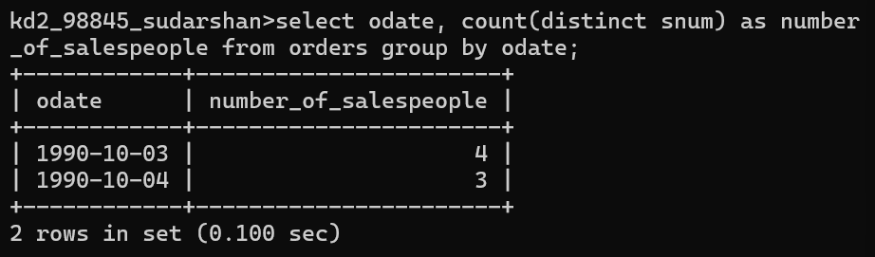

2. Write a query on the Customers table that will find the highest rating in each city. Put the output in this form: For the city (city), the highest rating is: (rating).
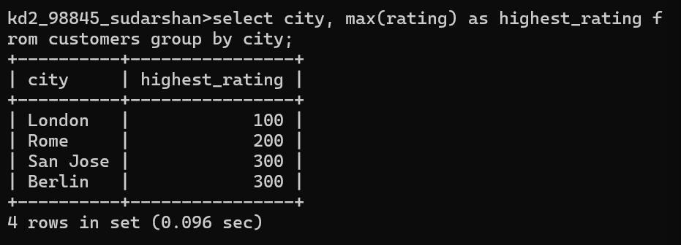

3 Write an SQL query to calculate the total order amount for each day and display the results in descending order of total orders.
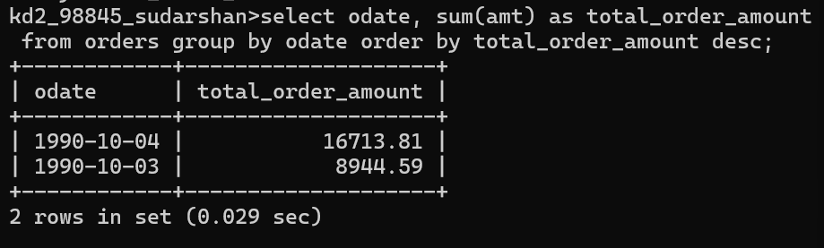

4. Write a query that selects the total amount in orders for each salesperson for whom this total is greater than the average amount of the order in the table. (Note Use the average amount value directly →2565.84)
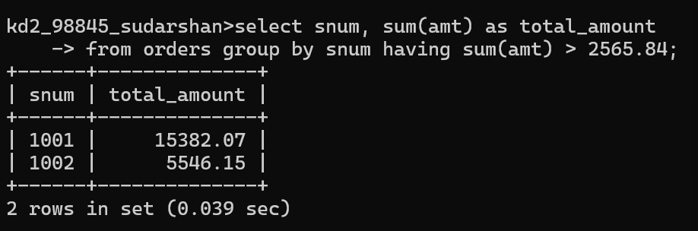

5. Write a query that selects the highest rating in each city.
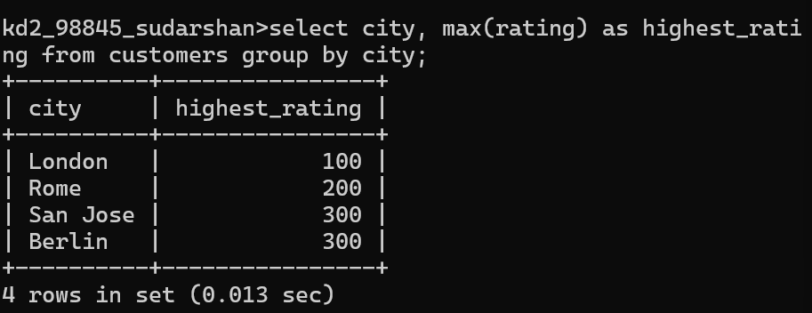

6. Retrieve the maximum order amount for each salesperson from the orders table, including only those orders whose value exceeds Rs. 3000.
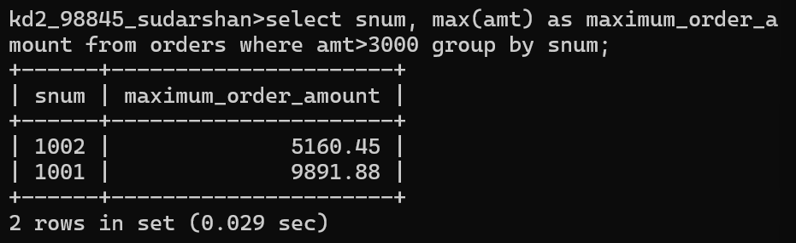
7. Write an SQL query to find the smallest order placed by every customer.
